Cairney School



Child Protection Policy

(August 2019) To be reviewed annually

Child Protection Guidelines

The practice and procedures outlined in this policy statement relate directly to Aberdeenshire Education and Children’s Services Policy and to the National Guidance for Child Protection in Scotland.

The Children Scotland Act 1995 highlighted each child or young person’s right to be protected from abuse, neglect or exploitation. The 1995 Act has been strengthened and broadened by the 2014 act which amongst other things legislates for the Getting it right for every child provision (Appendix 3) and extends the rights of the child by recognising the UN charter on the rights of the child within Scottish law.

Principles

- The first priority is the safety and well being of every child
- Prevention of abuse is as important as reacting to suspicions of abuse.
- Management of abuse must always reflect the possibility of criminal investigation and subsequent charges. However, the safety of the child has overriding priority.
- The child’s views should always be listened to and taken seriously.

What is Child Abuse?

“Abuse and neglect are forms of maltreatment of a child. Somebody may abuse or neglect a child by inflicting, or by failing to act to prevent, significant harm to the child. Children may be abused in a family or in an institutional setting, by those known to them or, more rarely, by a stranger.” National Guidance for Child Protection 2014 (Page 11).

Children with Disabilities

Research shows disabled children are approximately 3.6 times more likely to be abused or neglected than non-disabled children. Disabled children are particularly vulnerable to abuse and neglect, because they are more dependent on parents and carers to have their needs met. Children with communication difficulties may not be so able to tell anyone about their situation. Some children may not understand that what is happening to them is abuse or neglect. Caring for a disabled child can be very demanding at times, and places additional stress and exhaustion on parents/carers. At times this may impact on a parent’s ability to cope and meet their child’s needs safely. Children with disabilities often have more restricted social networks than non-disabled peers. This can increase their experiences of isolation and vulnerability.

There are a number of reasons why child protection concerns for children with disabilities are under-reported. It can be difficult to challenge parents already experiencing stress, and coping with the demands of caring for a disabled child. However it must always be remembered that whether abuse/neglect is intentional or not, the impact on the child is still detrimental and the risk must be responded to.

When children have communication difficulties or behavioural disorders, their attempts to communicate distress may be misinterpreted as being associated with their disability or condition. While communication with parents is important, we must also maintain professional curiosity and be mindful that children with disabilities can be abused and neglected by their parents. Most children with communication difficulties are able to use some method of communication, so it is vital that we seek children’s views and provide support which helps them to express themselves.

School staff have ongoing relationships with children, so are well placed to recognise changes in behaviour or presentation, or signs of distress in children with disabilities. Spending time with children, speaking with them, and our own observations (for example at arrival at school, or home time), can provide valuable opportunities to identify that child may be experiencing abuse or neglect.

Children and young people are also vulnerable to other forms of abuse and neglect. compared with their non-disabled peers. This includes:

Misappropriation of finances meant to benefit the child
Denying a child age/stage-appropriate opportunities for development and socialisation
Confinement to a room, bed/cot, or wheelchair
Lack of understanding about a disability leading to unrealistic expectations
Mocking or mimicking a child’s behaviour or speech
Rough handling or limiting calorie intake of non-mobile children, to make it easier to move/handle them

By maintaining professional curiosity, and always keeping the child at the centre, this helps us recognise and respond to abuse and neglect appropriately.

It is important that disability is not allowed to act as a barrier to exploring a child protection concern further. While Child Protection Investigations are undertaken by trained social work/police staff, information from schools is invaluable. It contributes to the understanding of a child’s additional needs, communication methods, and individual characteristics

There are 4 indicators of risk:

Physical abuse | - Physical abuse may involve hitting, shaking, throwing, poisoning, burning or scalding, drowning or suffocating.  - Physical harm may also be caused when a parent or carer feigns the symptoms of, or deliberately causes, ill health to a child they are looking after.
Emotional abuse | - It may involve conveying to a child that they are worthless or unloved, inadequate or valued only insofar as they meet the needs of another person.  - It may involve the imposition of age- or developmentally-inappropriate expectations on a child. It may involve causing children to feel frightened or in danger, or exploiting or corrupting children.
Sexual abuse | - Involves forcing or enticing a child to take part in sexual activities, whether or not the child is aware of what is happening. The activities may involve physical contact, including penetrative or non-penetrative acts. They may include non-contact activities, such as involving children in looking at, or in the production of, pornographic material or in watching sexual activities, using sexual language towards a child or encouraging children to behave in sexually inappropriate ways.

Neglect | - Neglect is the persistent failure to meet a child's basic physical and/or psychological needs, likely to result in the serious impairment of the child's health or development.  - It may involve a parent or carer failing to provide adequate food, shelter and clothing, to protect a child from physical harm or danger, or to ensure access to appropriate medical care or treatment.  - Neglect may also result in the child being diagnosed as suffering from 'non-organic failure to thrive', where they have significantly failed to reach normal weight and growth or development milestones and where physical and genetic reasons have been medically eliminated.  - In its extreme form children can be at serious risk from the effects of malnutrition, lack of nurturing and stimulation. This can lead to serious long-term effects such as greater susceptibility to serious childhood illnesses and reduction in potential stature. With young children in particular, the consequences may be life-threatening within a relatively short period of time

Indicators of risk also includes Child Sexual Exploitation, Trafficking and Female Genital Mutilation, Forced Marriage.

Procedures (Appendix 1)

The behaviour you might see which might indicate a potential child protection or wider wellbeing problem for a child includes:

Physical Indicators | Behavioural Indicators
Frequently dirty, hungry or inadequately dressed | Inappropriate sexual awareness or sexually active
Left in unsafe situations or without medical  attention | Domestic violence in the home
Constantly put down, insulted or sworn at | Drug alcohol abuse in the home
Seems afraid or parents /carers | Unexplained changes in behaviour
Unexplained bruising in soft tissue areas, black eyes, repeated injuries | Difficulty in making friends
Burns, scalds & bites | Distrustful of adults
Marks from implements | Excessive attachment to adults
Injuries to the mouth | Reluctance to go home
Inconsistent stories about the injuries | Reluctance to remove clothing
 | Change in attendance pattern

The designated Child Protection Coordinator for Cairney School is the Head Teacher. If a member of staff has any concerns relating to a child at risk from any form of abuse, the following procedure must be followed:

Discuss your concerns immediately with the Head Teacher or in the absence of the Head Teacher, the Depute Child Protection Coordinator (the Head Teacher of Forgue School).

Any concerns about a child or young person’s wellbeing must be shared. Do not take concerns home …if there is any doubt to a child or young person’s welfare it must be passed on.

There are 3 key questions in Child protection:
- Is this child or young person at immediate risk?
- What is placing this chid at immediate risk?
- What needs to happen to remove this risk now?

If the answer to the first question is yes then Child Protection protocols must be followed immediately.

What do you do if a child discloses information to you?

Observe, Record, Report

- Stay calm. Try and not to react by showing any feelings of horror etc you may have. The child will read this as being a feeling you have about them rather than what has happened to them.
- Give reassurance - remind them that they are not to blame and are doing the right thing by speaking up.
- Allow the child to speak, only ask enough questions to understand what you think you have just been told.
- Do not change/correct the child’s language.
- Do not promise to keep secrets.
- Let the child know you take their concerns seriously.
- Do not offer new information by suggesting reasons for why someone did what they are alleged to have done.
- We have a responsibility to share this information and we need to let children know this in a sensitive way.
- Do not investigate the situation. Do not ask leading questions, listen.
- Pass the information on to the Child Protection Coordinator who will decide next steps, e.g. contact social work.

Recording (Appendix 2)

- Make clear and concise, factual notes. Sign and date these.
- Record by hand as soon as possible. Your notes must be/include
  - Factual, Accurate, Timely
  - Signs of physical injury (no photos)
  - The behaviour and emotional state of the child
  - Your Actions
  - Confidential
  - Signed and dated

- Remember that the role of the school is to observe, record and report. Investigation is not the responsibility of Education and Children’s Services.
- If you cannot contact the appropriate person, and there are immediate concerns for the child’s safety, seek advice from another establishment Head Teacher. If the incident happens out of hours , or it is not possible to speak to any school contacts, then it is important that you do not wait but immediately contact the duty social worker or ‘Out of Hours Social Work Service’: 0845 8400070, or if you believe a crime has taken place, you contact Police directly: Police Scotland 101 or Police Emergency 999

If after discussion with the Child Protection Coordinator, the decision is to take this forward as a Child Protection Concern:

- The Child Protection Coordinator will make contact with the Social Work Service to discuss the situation using the referral checklist. This will be followed up with an electronic record of the child protection form within 48 hours.
- Remember that Social Work has a responsibility to provide feedback to the referrer. If this does not happen it is the referrer’s responsibility to seek a response and record it.
- It is important to support the child. They should be reassured, and kept in a place of safety within the school until advice is received from the Social Work Service.

Records

- A Child protection Education Case File will be opened and a copy of the referral form will be included.
- The pupil chronology will be moved from the PPR to this file.
- A blue dot will be placed on the child’s PPR.
- A copy of the referral form will be sent to the Social Worker and the QIO within 48 hours.

Adult Protection

School staff may also become aware of a parent or carer who is believed to be an “Adult at risk” This is based on a 3 point test and defined as an adult who:

(a) Is unable to safeguard their own well-being, property, rights or other interests,
(b) Is at risk of harm, and
(c) because they are affected by disability, mental disorder, illness or physical or mental infirmity, are more vulnerable to being harmed than adults not so-affected.

You can call the Adult Protection network on 01467 533100 for advice

Staff Training

Cairney School is committed to ensuring that all staff receive adequate training to ensure that they are confident, well informed, supervised and supported to promote the protection of children; and are aware of, and adhere to Council Policy and National Guidelines. Child Protection awareness raising will be delivered to all teaching and non-teaching staff on the first day of each school session and induction of new staff will include the Child Protection Policy.

Education and Children’s Services are committed to ensuring that a rolling programme of training is in place for Child Protection Coordinators and all staff. Staff annual reviews will identify child protection training needs and these will be addressed through appropriate training. In addition, the Head Teacher will ensure that child protection training courses are brought to the attention of staff.

Note:
- Details of the ECS Child Protection Training Courses can be found on ALDO.

Attendance and Absence Management

All new pupils will be issued with child protection attendance information detailing parents/carers responsibility to contact the school if their child is absent. This information will be re issued every August.

Procedure to track pupil absence

- Parents are asked to phone school by 9.15am
- Staff receiving a phone call/ verbal message from a parent should notify the office immediately.
- Any missing children should be reported to the office following morning and afternoon registration
- Any queries regarding pupil absence will be followed up by office staff immediately and registers amended accordingly.
- Office staff have a duty to contact parents/emergency contacts/other known relations in order to locate any missing child. The Head Teacher should be informed of any unexplained absences no later than 9.30am.
- Office staff will enter attendance/absence information to SEEMIS

If a parent/carer is not contactable and the child is missing, Cairney School will follow ECS Policy and procedures

If a child is moving school to ensure the pupil is safe and attends another school the school will follow ECS Policy to ensure safe transfer from one school to another.

Named Person

The Named Person is the individual who acts as the central point of contact for a child and their family. They develop a supportive relationship based on promoting the wellbeing of a child or young person. These responsibilities would already sit within the current professional roles of Teachers and Health Visitors.

The Named Person role includes: Provision of advice, information, accessing support for a child, young person, or parent from within their own service, and helping the child or family access external services or support where this is required.

Named Persons have a role in ensuring that the full range of support available within Universal Services, has been sought and provided to a child or young person where needed.

It is national policy for organisations to make a Named Person Service available to every child, but there is no obligation for children, young people, or parents to accept any offer of advice or support from Named Persons. Non-engagement with the Named Person is not in itself a cause for concern, and does not change our ways of working in line with statutory professional roles.

Named Person Responsibilities:

- Promote, Support and Safeguard Wellbeing
- Central point of contact and key relationship supporting the child and family
- Advice, information, providing or accessing support
- Early Intervention/Prevention and Single Agency Assessment

We all have a role in making sure we promote, support and safeguard the wellbeing of all children or young people. Everyone in this school is responsible for taking forward their own professional responsibilities, and making sure we provide the best available support to children and families. This is done by working alongside and supporting the Named Person in their role, whether on a Single Service or Multi-Agency basis.

Information recorded in Pastoral Notes should always reflect this approach, and bear in mind any information recorded may be accessed in future by the child or family, or shared with other professionals. Always be professional, concise, accurate, and relevant when recording information within a child’s records in school and SEEMiS systems.

Further Support Available:

- Protecting Children in Aberdeenshire Booklets
- Aberdeenshire GIRFEC website
- National Child Protection Guidelines 2014
- Designated staff in Schools; Child Protection Co-ordinator (and Depute CPC), Head teacher (Primary)
- Multi Agency Learning and Development

List of Appendices

- School Procedures: dealing with child abuse
- Child protection Incident Sheet
- GIRFEC Wellbeing Wheel

Policy Review

This policy will be reviewed annually by all teaching and non-teaching staff on the first day of each school session.

August 2019

Appendix 1
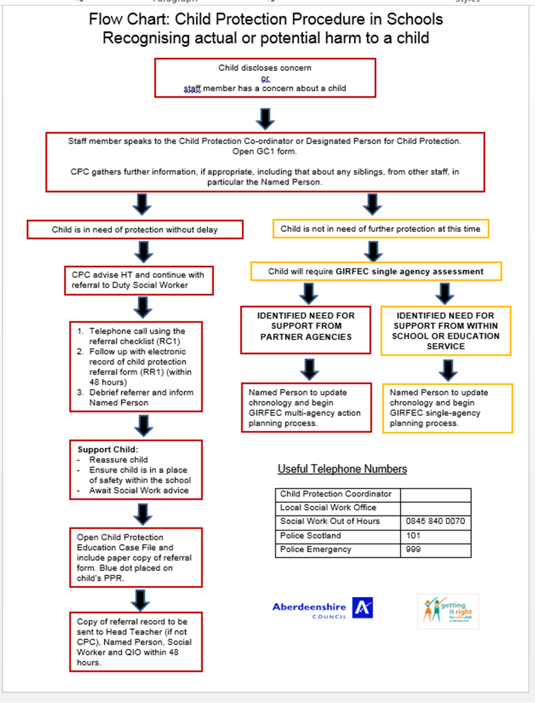

Appendix 2 CHILD PROTECTION: RECORD OF INCIDENT

Cairney School Member of staff ………………………………

Name of Child …………………………......... DOB ……………….. Gender ………..

Date | Incident | Action Taken

Appendix 3


